National Taipei University of Technology Degree Dissertation Originality Comparison Checklist（Final version）
05.15.2025

Institute Name:
Name:
Student ID No.:
Dissertation Topic:
- Does the total similarity index in the originality report exceed 20%？
 No
 Yes, please specify the reasons:
- Does the top index of the primary sources in the originality report exceed 2%？
 No
 Yes, please specify the reasons:
※According to Ministry of Education’s meeting on 2022/1/21, the similarity index is not the only standard to examine academic ethics. Make sure you read through the whole originality report and confirm each source.
I (sign) have used the NTUT “Turnitin Dissertation Comparison System” to examine my dissertation. A copy of the originality comparison report and the confirmation email are attached. I have examined my dissertation and should take legal liability for this if any violation of academic ethics in the thesis is confirmed true.
Signature of Student of Degree Dissertation Final version:
Date: (YYYY/MM/DD)
Signature of Advisor:
Date: (YYYY/MM/DD)
Note：
- Each graduate student shall complete the dissertation originality comparison before the departure procedures. Fill out this checklist and submit along with the originality comparison report to the advisor for signature.
- This checklist does not require a review email from the library. Graduate students should upload a scanned copy of this form to System of Academic Affairs- Graduation Procedures System when completing the student graduation exit processes.
- The similarity percentage index of Turnitin's dissertation comparison system is provided for the reference of the faculty and its advisor only but does not prove whether the dissertation is legal in academic ethics.
Instructions for Completion
(1) Please upload the final version of your thesis to the Turnitin system for similarity checking.
(2) This checklist does not require library review. Please refer to the example image below to check the similarity percentage yourself.
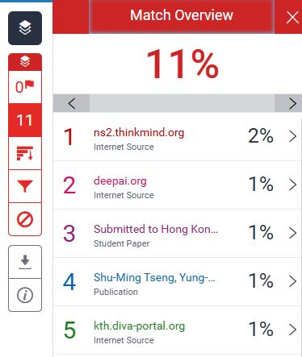
← total similarity index
← top index of the
primary sources

Click here→

